

Revenue Leakage

USER MANUAL GUIDELINES

2018

**Revision History**

|  |  |  |  |  |  |  |
| --- | --- | --- | --- | --- | --- | --- |
| **No.** | **Version** | **Release Date** | **Author** | **Reviewer** | **Revised Sections** | **Remarks** |
| 1 | .01 |  | Sarika Singh |  |  |  |
| 2 | 2 |  | Shankar Dutt Mishra |  |  |  |
|  |  |  |  |  |  |  |
|  |  |  |  |  |  |  |
|  |  |  |  |  |  |  |

|  |
| --- |
|  |

Table of Contents

1. Introduction 3

1.1 Objective of the Manual 3

1.2 Intended Audience 3

1.3 Organization of the manual 3

1.4 Glossary of Terms 4

1.5 Systems Requirements 4

2. Getting Started in Revenue Leakage Platform 5

2.1 Login 5

2.2 Home Page 6

2.3 Log Out 7

3. Dashboard 7

4. Pre Bill Account Review List 11

5. Post Bill Account Review List 20

6. Confirmed Charge View 29

7. Edit Submitted Accounts 31

8. Coding edits Accounts 32

9. Coding Edits Submitted Accounts 40

1. Introduction

Revenue Leakage is the difference between the revenue healthcare providers are entitled to and the amount of reimbursement actually received. Huge amount of reimbursements are lost due to inaccurate pricing and charging.

Healthcare organizations realize they’re missing revenue but they are unable to detect the source of leakage.

So how do we identify and prevent Revenue Leakage?

The Revenue Leakage application has been highly effective in addressing this core issue. It uses advanced analytic models to detect outlier behaviour and score patient invoices based on the likelihood of missing or incorrect charges. Then it prioritizes and rank-orders the patient invoices with the highest scores as well as highest potential positive bottom-line impact based on total dollar value of each missing charge and expected reimbursement from the payer. The prioritized invoices are then reviewed by nurse auditors to confirm whether the predicted charges are, in fact, missing, thus allowing expensive auditing resources to be focused only on the highest priority review items. Once confirmed, the missing or incorrect charges are edited and added to the patients’ accounts.

It incorporates feedback provided by the auditors to continuously refine the analytic models and even more intelligently prioritize missing charges. Its output can be adapted to the latest billing procedures and guidelines by superimposing facility-specific protocols to the core data.

Some of the benefits of using this application are listed below.

* Find charges more accurately
* Enhances productivity
* Accurate and Efficient
* Software requires no IT investment

It is very user friendly and it is an easy system to navigate.

1.1 Objective of the Manual

The objective of this manual is to provide assistance to the users ensuring effective use of the features and functionalities of the Revenue Leakage Platform application. The manual provides step-by-step descriptions of the functionality within the Dashboard, Pre-bill Account List, Post-Bill Account List pages, Edit submitted accounts, Coding Edits and Submitted Coding Edits.

## 1.2 Intended Audience

The intended users of this manual are:

* Auditors
* Supervisors

Access to the application is through the role and per­mission privileges.

## 1.3 Organization of the manual

The Revenue Leakage User Guide includes the following chapters:

* Dashboard
* Pre bill Account List
* Post Bill Account List
* Confirmed Charges
* Edit Submitted Charges
* CCI Edits
* Submitted CCI Edits

## 1.4 Glossary of Terms

* Dashboard:
* Pre-bill :
* Post-bill:

## 1.5 Systems Requirements

In order to use the Revenue Leakage application all end users must access it through a web browser. Supported web browsers are Firefox, Chrome, Internet Explorer, Version8 or later. In addition, the only end users who are permitted to access the Revenue Leakage Platform application are those that are authorized. (Describe Browser Settings)

# **Getting Started in Revenue Leakage Platform**

## 2.1Login

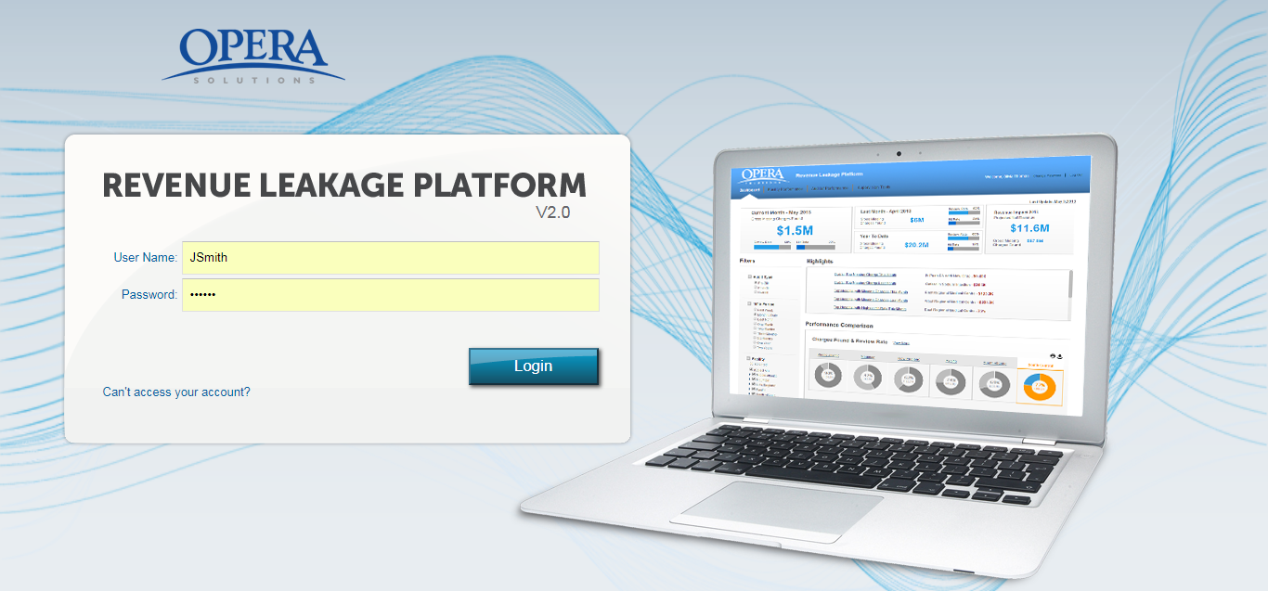

Figure 1: Login screen

**Step 1:** The applicationcan be accessed by entering the following URL into the   
 address box:

_________________________________________

**Step 2:** Enter your **Username** and **Password**.

**Step 3:** Click **Sign In**

**Step 4:** After entering the correct username and password, user is redirected to the   
 Home page of Revenue Leakage Platform.

## 2.2 Home Page

The Home page has following four tabs. By default, **Dashboard** tab is selected.

1. Dashboard: The Dashboard page provides a snapshot of all the facilities (hospitals) which have been assigned to an auditor for pre-bill and post-bill. It provides information about completed and pending accounts across various hospitals. The end user is able to view other details like the review rate and the missing charges across various hospitals for last five months.
2. Pre-Bill Account Review List: It shows all the pre-bill prediction accounts of different hospitals assigned to an auditor. It provides information like Review rate, Hit rate and the missing charges for different hospitals starting from last month till current month.
3. Post-Bill Account Review List: It shows all the post-bill prediction accounts of different hospitals assigned to an auditor. It provides information like Review rate, Hit rate and the missing charges for different hospitals starting from last month till current month.
4. Confirmed Charges View: It shows all the pre-bill and post-bill accounts with missing charges on which auditor has agreed upon. The end user has the option of downloading this summary report in an excel format.
5. Submitted Account View: It shows all the submitted pre-bill and post-bill accounts with missing charges on which auditor has agreed upon.  This functionality can be only used on the same day of submission of the account before consolidated reports are sent to facilities.
6. CCI edits Account Review View: It shows all the pre-bill prediction accounts of different hospitals assigned to an auditor. It provides information like Review rate, Hit rate and the missing charges for different hospitals starting from last month till current month.
7. Submitted CCI edits Account Review View: It shows all the pre-bill prediction accounts of different hospitals assigned to an auditor. It provides information like Review rate, Hit rate and the missing charges for different hospitals starting from last month till current month.

## 2.3 Log Out

You can log out of the application from any screen by clicking on the **Log Out** link from the   
 header bar.

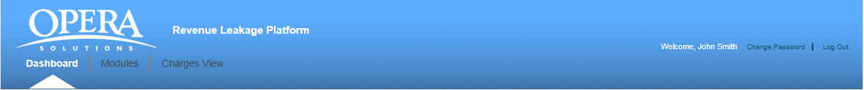

Figure 2: Logout Screen

You are logged out of the application and the Login screen is displayed.

# **Dashboard**

The dashboard page shows all the facilities (hospitals) which have been assigned to an auditor. It provides information about the total accounts completed, accounts remaining and missing charges for both pre- bill and post -bill accounts.

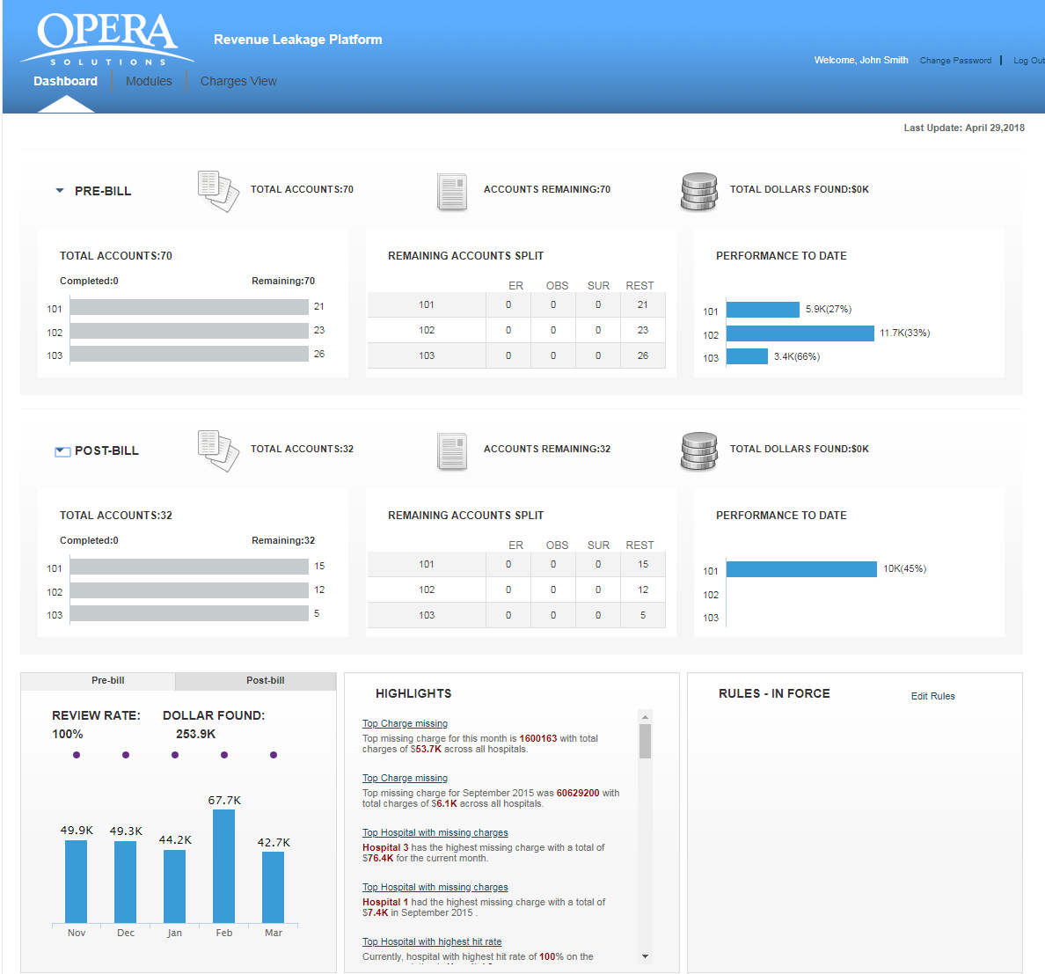

The dashboard is divided into four main segments:

1. **PRE-BILL**
2. **POST-BILL**
3. **CODING EDITS (Configurable)**
4. **Other segment**

**PRE-BILL:** The pre bill segment is divided into three separate widget areas:

* **Total Accounts:** It shows a bar chart to indicate total accounts completed against total accounts assigned for each facility. If you place your mouse over a specific horizontal bar in the graph, a tool tip appears which shows total accounts completed and remaining for that particular facility. If you click on any facility, system will navigate to the Accounts Review page.
* **Remaining Accounts Split widget:** The auditor is able to view all the accounts in a tabular format. It shows the data breakup for following department across different facilities that have any accounts remaining.
* Emergency(ER)
* Observation(OBS)
* Surgery(SUR)
* Rest: it shows all other department accounts which are not part of the above accounts.

If you click on any Facility Id, system will navigate to the Accounts Review List page with the facility ID selected.

* **Performance till Date:** It shows the performance of the auditor from the beginning of the month till current date.

In the above screenshot, for Facility ID 822, the missing charges found across all the accounts is 2.81K and the hit rate (percentage of accounts on which the auditor has agreed for the missing charges) is 100%.

The end user can collapse the segment by clicking the triangle next to the PRE-BILL.  . Click the triangle again to expand that part of the segment.

**POST-BILL:** The auditor is able to view all the post bill accounts across different hospitals   
 which are assigned to him. The post bill segment is divided into three separate widget areas:

* **Total Accounts:** It shows a bar chart to indicate total accounts completed against total accounts assigned for each facility. If you place your mouse over a specific horizontal bar in the graph, a tool tip appears which shows total accounts completed and remaining for that particular facility.
* **Remaining Accounts Split widget:** The auditor is able to view the remaining accounts in a tabular format. It shows the data breakup for following department across different facilities that have any accounts remaining.
* Emergency(ER)
* Observation(OBS)
* Surgery(SUR)
* Rest
* **Performance till Date:** It shows the performance of the auditor from the beginning of the month till current date.

**CODING EDITS (A3) :** The CMS developed the National Correct Coding Initiative (NCCI) to promote national correct coding methodologies and to control improper coding leading to inappropriate payment. Opera has developed algorithm for healthcare clients to avoid such improper coding while submission of bill to payers. These NCCI Edits can be categorized into three cattegories: **PTP , MUE and Add-on** code edits.

The auditor is able to view all the edits based accounts across different hospitals which are assigned to him. The post bill segment is divided into three separate widget areas:

* **Total Accounts:** It shows a bar chart to indicate total accounts completed against total accounts assigned for each facility. If you place your mouse over a specific horizontal bar in the graph, a tool tip appears which shows total accounts completed and remaining for that particular facility.
* **Remaining Accounts Split widget:** The auditor is able to view the remaining accounts in a tabular format. It shows the data breakup for following department across different facilities that have any accounts remaining.
* Emergency(ER)
* Observation(OBS)
* Surgery(SUR)
* Rest
* **Performance till Date:** It shows the performance of the auditor from the beginning of the month till current date.

**Other segment:** It shows three widgets:

* **Pre bill/ Post Bill/Coding Edits Overall performance for last five months:** The auditor is able to view his performance for last five months for both PRE-BILL and POST-BILL accounts. A line chart is used to display the information for the review rate (percentage of accounts reviewed by the auditor) whereas a bar chart is used to depict the information about the missing charges found. If you place your mouse over the bar chart or the line chart, a tool tip appears which shows the “**Missing Dollars”** and the “**Review Rate”** for that specific month. When you click on the Post –Bill tab, it will display the data for the post bill accounts.
* **Highlights:** Displays the latest updates about the important activities or information in the application. The activities are broadly classified into different categorieslike “Top Charge Missing”, “Top Hospital with Missing Charges”, “Top “Hospital with highest hit rate” and “Top department with missing charges”. By default, it will show the top five entries and will show all latest updates when the end user expands the dashboard item.
* **Rules in force:**

# **Pre Bill Account Review List**

It shows all the **PRE-BILL** accounts of different hospitals which have been assigned to an   
auditor. For viewing accounts of a particular hospital, select the hospital ID from the filter panel available on the left side and the application will display all the accounts of that particular facility.

If no account is pending for review, the auditor will get the message **“No Account Review is   
 “Pending for the Facility”.**

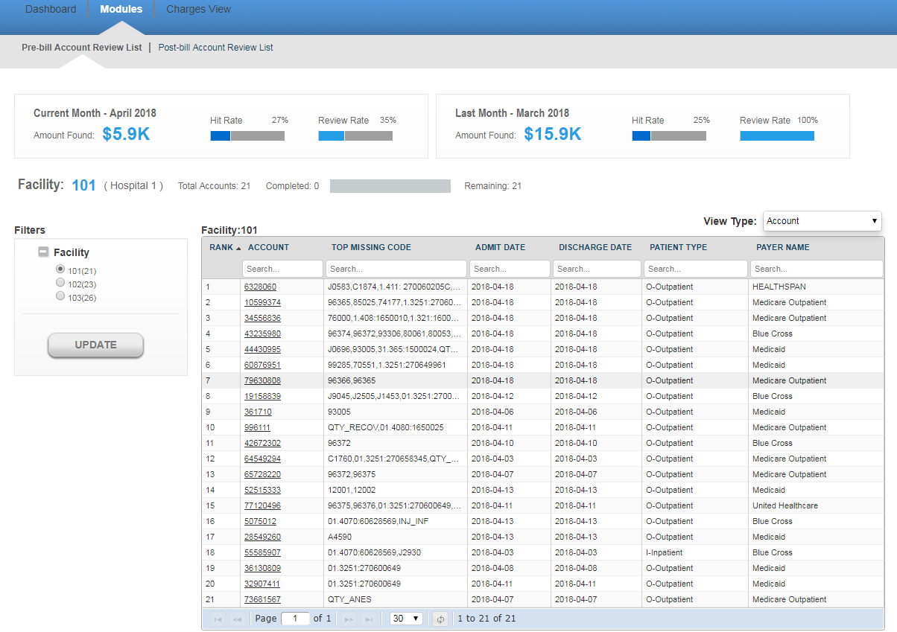

**View Type** : Grouping accounts based on Code and payer. There are 3 options available in dropdown.

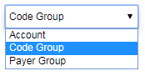

* **Account (Default)**
* **Code Group**
* **Payer Group**

**Account** : This the default view for showing accounts. accounts are coming based on hospitalId and accountId

**Code Group**: - This is showing tree view of accounts based on [hospitalId-accountid-predcodeClassifications]. 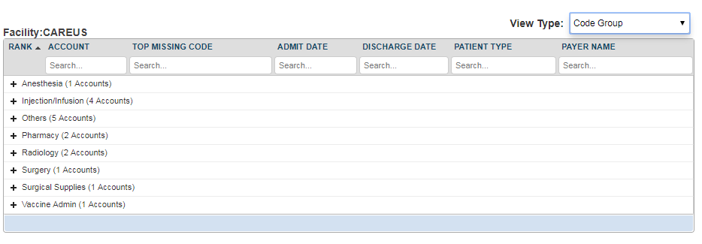

**Payer Group**:- - This is showing tree view of accounts based on [hospitalId-accountid-PayerCode].

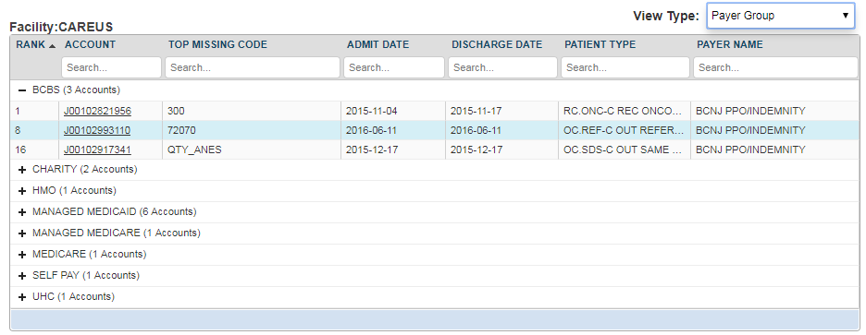

You will view the following details for a particular account.

* **Account:** It refers to the patient identification number.
* **Top Missing Code:** It refer to the missing code find for this account.
* **Admit Date:** It is the date when patient got admitted to the hospital.
* **Discharge date:** This is the date when patient got discharged from the hospital.
* **Patient Type:** There can be different types of patients. For example, OUTPATIENT, INPATIENT and EMERGENCY.
  + OUTPATIENT care is any healthcare service provided to a patient who is not admitted to a hospital.
  + INPATIENT care is any healthcare service provided to a patient who is admitted to a hospital.
  + EMERGENCY care is provided to the patients who need urgent care because of the illness or accident.
* **Payer Name:** This is the name of the insurance company.

All the above fields are searchable. You can navigate through multiple pages of records by making use of navigation bar given at the bottom of the screen. Enter a specific page number and you will jump to that specific page.

Above the account’s grid, you will view two widgets for other details like the **Amount Found**, **Hit Rate** and the **Review Rate** for the past month and the current month.



**Hit Rate:**  It refers to the percentage of accounts on which the auditor has agreed for missing charges.

The Hit Rate of an auditor can be calculated by using the below formula:

**Number of accounts Agreed / Total number of reviewed accounts**

**Review Rate:** It refers to the percentage of accounts reviewed by the auditor.

The Review Rate of an auditor can be calculated by using the below formula:

**Number of accounts Reviewed by an auditor/Total number of accounts assigned to an auditor**

Click on any account and you are directed to the “**PRE-BILL ACCOUNT DETAILS“**  page.

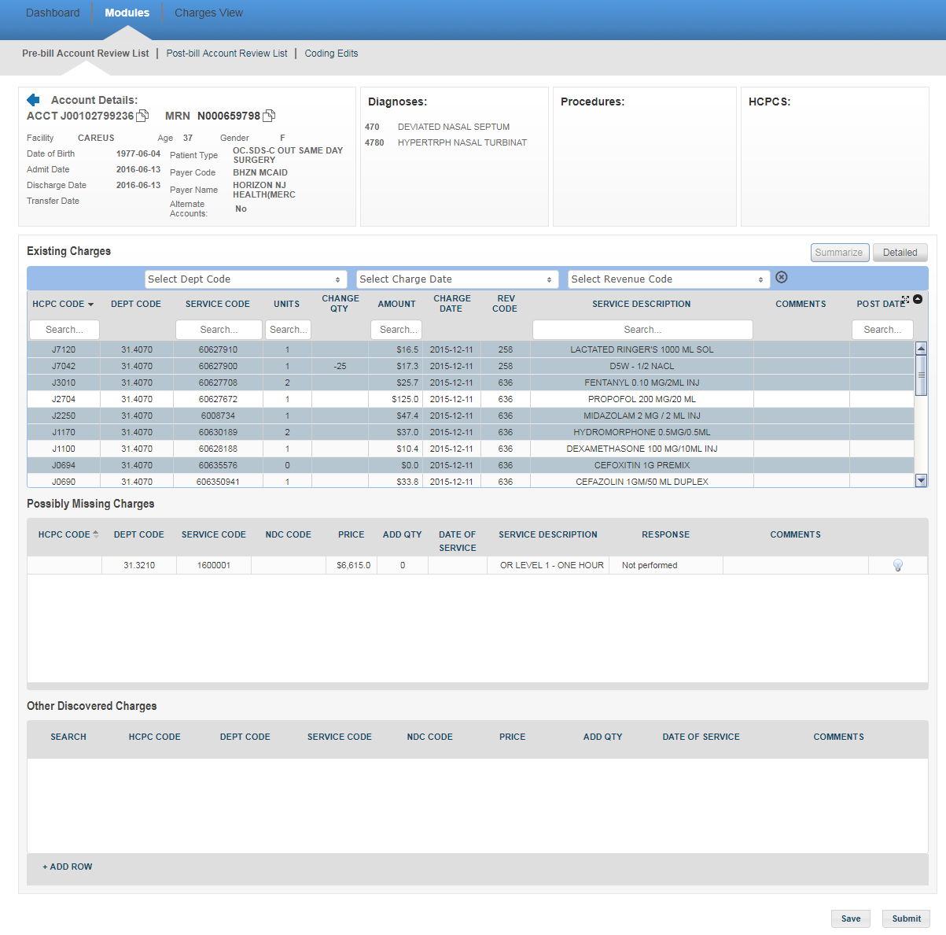

The user can view the account’s personal information like Age, Gender, Date of Birth, Admit Date, Discharge Date, Transfer Date, Patient Type, Payer Code and the Payer’s name on the top-left of the screen. You can also see information about alternate accounts for the same patient (An alternate account is an account with the same Patient ID and same Admit or Discharge Date as the original account). Towards the right, you will find the details about various diagnoses codes, Procedure codes and HCPCs on the account.  You can also use the scroll bar in individual Diagnosis/Procedure/HCPC sections in case the list is long.

You will view **“Existing Charges”, “Possibly Missing Charges”** and **“Other Discovered Charges”**below.

**Existing Charges:**  These charges will include all the hospital charges for treatment and services rendered to the patient. The auditor will audit these charges and can make changes in the quantity, enter his comments and can directly submit the data OR save the information for later purpose without submitting. In the existing charges section, there are two alternate views that the auditors can toggle between. The **Summarized** view is a summed-up view based on the HCPC/charge Code, department, charge date and description. The **Detailed** view is the usual detailed existing charges view. A Blue row in summarized view indicates that once you expand to Detailed view, you’ll be able to see multiple transactions for the same charge.

There are three filters at the top (**Dept Code, Charge Date, and Revenue Code**) using which you may filter the data that is shown in the existing charges table. In the dropdown, you should be able to see the code, description and the total charges amount for the same. Please find below, a screenshot of the same with the dropdown for Revenue Code.

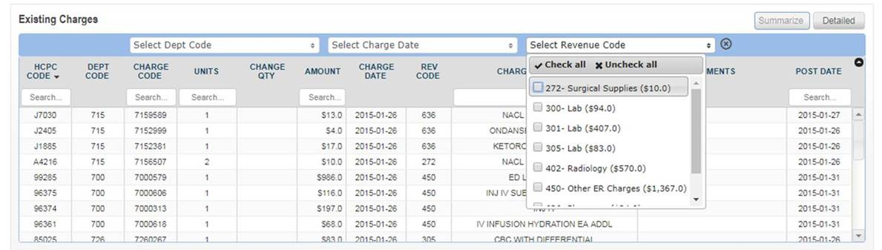

You may select **multiple codes from each of the filters** as per preference and the below table would get updated with the corresponding data. For example, if you were to select revenue codes 272, 300, 301 and dept code 723 in the above table, the below view would be shown. You may click on the cross on the right of the last filter to remove all filters selected.

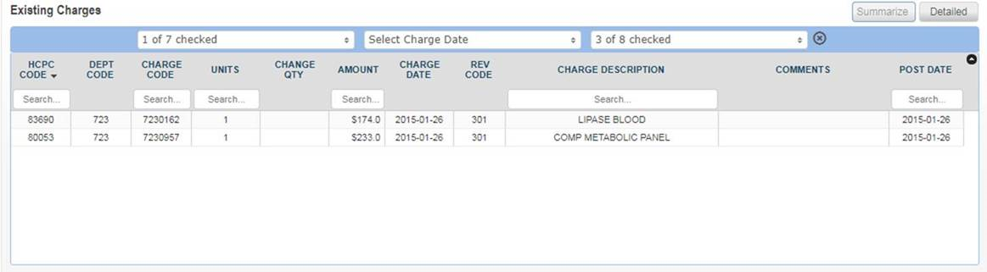

The Existing Charges grid has following columns:

* HCPC Code: This is the healthcare common procedure code.
* DEPT Code: This is the department code of the patient.
* Charge (Service) Code: This is the code associated with the charge in a facility and department
* Units: This is the medication dose which is given to a patient.
* Change Quantity: If an auditor feel there should be some change in quantity, he can change the quantity and enter the updated quantity.
* Amount: This is the amount of the units consumed by the patient.
* Charge Date: This is the date on which the patient is charged.
* Rev Code: This is the revenue code associated with the charge code
* Service Description: This is a brief description about the various charges incurred on the patient.
* Comments: The auditor can write his comments in the area provided.
* Post Date: This is the date when the charge was added to the account

You may also search for codes on the account by typing in the search box below each column in the table.

**Possibly Missing Charges:**We use our software solutions to identify missing charges. The auditor can audit the missing charges and give the response.  If auditor agrees for missing charges for an account, the response “**Agree**” can be selected, else any other response from the drop-down list can be selected. After selecting the response, please enter comments as well.

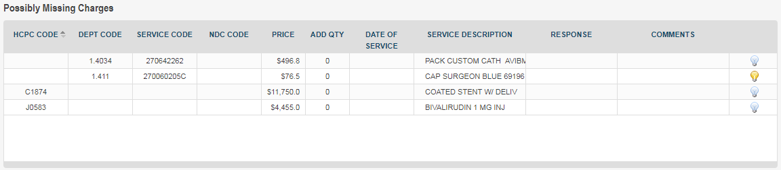

The possibly missing charges grid has following columns:

* HCPC Code: These codes are numbers assigned to every task and service a medical practitioner may provide to a patient including medical and diagnostic services.
* DEPT Code: Each department in a hospital has a specific code. It conveys essential information quickly without any misunderstanding.
* Charge (Service) code: This is the code associated with the charge in a facility and department
* NDC Code: This is a code used for Pharmacy charges
* Price: This refers to the price of the item/procedure
* ADD QTY: This is the quantity of the item to be added
* Date of Service: This is the date on which the charge is administered.
* Charge (Service) Description: This is a brief description about the various charges incurred on the patient.
* Response: The auditor can select the response from the drop-down list. If the agrees for the missing charges, he can select the option “Agree”from the drop down list. Accordingly, he can select a different response from the drop down list based on his review. For example, if the auditor feels there is no documentation for this account, he can select the option “Documentation is not available for review”.
* Comments: The auditor will enter his comments in the area provided.
* Tool tip (Lightbulb): This feature can be used to share knowledge obtained on review of same code previously across auditors. It is basically a comment box which can be used by auditors to add information to make it easier for other auditors reviewing the same code. If the bulb is yellow, it means that there are comments already added for the prediction.

**Other Discovered Charges:** These are the charges other than the existing and the missing charges.  This option enables the auditor to add some other miscellaneous charges which could have been missed for a particular account. The auditor can easily search the details even if he knows initial two or three letters of  “**Department Code**” or “**Charge Code**”.

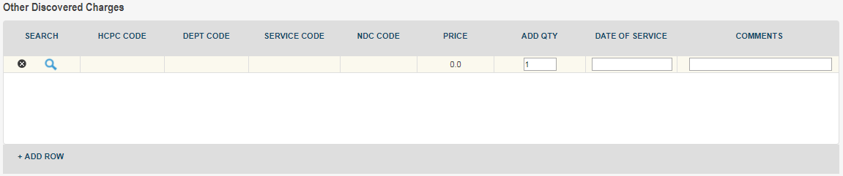

The “Other Discovered Charges” grid has following columns:

* Search: This allows the auditor to search the code to be added in the row
* HCPC Code: These codes are numbers assigned to every task and service a medical practitioner may provide to a patient including medical and diagnostic services
* Department Code: Each department in a hospital has a specific code. It conveys essential information quickly without any misunderstanding.
* Charge (Service) Code: This is the code associated with the charge in a facility and department
* NDC Code: This is a code used for Pharmacy charges
* Price: This refers to the price of the item/procedure
* Add Quantity: This is the quantity of the item to be added
* Date of Service: This is the date on which the charge is administered
* Comments: The auditor will enter his comments in the area provided

The auditor can click on the plus (+) sign  to add a new row to the grid. Clicking on the Search icon will display the “**Other Discovered Charges search form”.**

In search mode, you may use the drop down box to select key criteria by which to search and you may enter those criteria in whole or part. It has four options available for doing the basic search.

1. Equals
2. Begins with
3. Ends with
4. Contains

* **Equals**: The search results will include only the letters you specify.  For example, entering “LINEN SAVERS” as your search string for “Service description” would return only one result for the given charge description. Similarly, if you enter “5412”as the “Service code”.  It will display the record with the matching charge code.
* **Begins with**: The search result will have all of the letters in the beginning which you entered in the search criterion.  For example, entering “Department Code” as “41” will return any Department Code that begins with “41”.
* **Ends with**: The search results will have all the letters or numbers included   in the end.  For example, entering “12”as a search string for  “ Department  Code”  will fetch records  like “312”, “412”, “512” .
* **Contains**: The search results will have all of the letters   included anywhere in the results which you entered as a search criterion.  For example, entering “Emer” as your search String for “Department Description”   might return results like “Emergency”, “Emergency OPD”, “Emergency Cardiac” etc.

There are four steps to perform a basic search.

1. Select the search criterion from the drop down box.
2. Enter all or part of the search string.
3. Click the **“Submit”**
4. Review the search results and select the appropriate record.

In the screenshot below, we see that the user elected to search by “**Department code”** using “**equals”** as search criterion.

The auditor can select any specific record and double click on it. The values will be populated in the “**Other Discovered Charges**“ grid.  The auditor can enter his comments on the same.

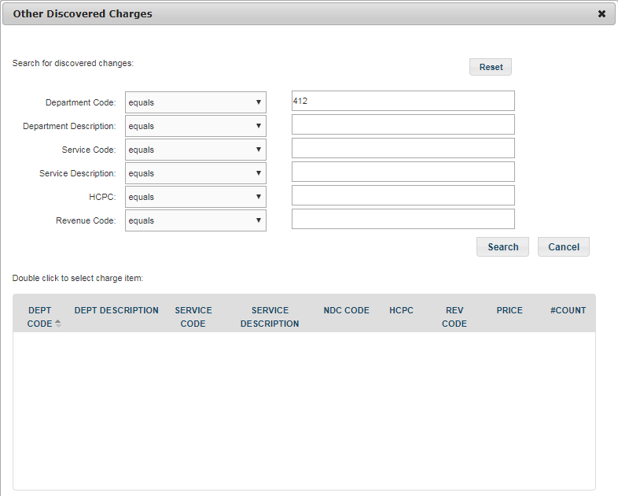

The auditor can enter the information and click on “**Save”** button. The information will be saved and the account’s row will be highlighted in blue Color in **“Accounts Review** **List”** page. When the auditor logs into the application next time, he knows that changes have been done for this account but they are not yet submitted.   If the auditor clicks on the **“Submit”** button, the information gets saved and the account is removed from the **“Accounts Review List”** page.

# 5. **Post Bill Account Review List**

It shows all the **POST-BILL** accounts of different hospitals which have been assigned to an   
auditor. For viewing accounts of a particular hospital, select the hospital ID from the filter panel available on the left side and the application will display all the accounts of that particular facility.

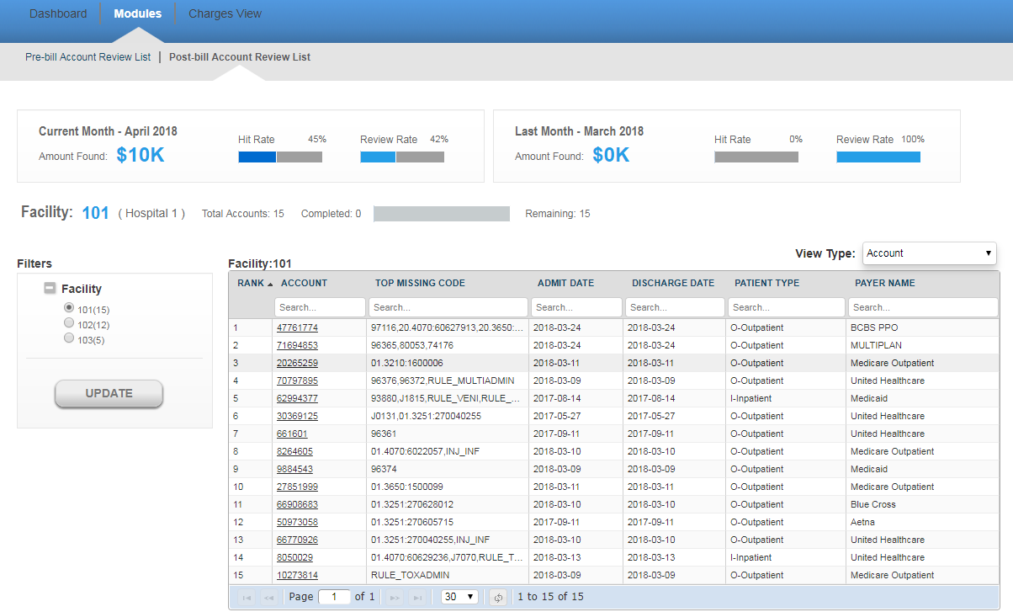

If no account is pending for review, the auditor will get the message **“No Account Review is   
 “Pending for the Facility”.**

**View Type** : Grouping accounts based on Code and payer. There are 3 options available in dropdown.



* **Account (Default)**
* **Code Group**
* **Payer Group**

**Account** : This the default view for showing accounts. accounts are coming based on hospitalId and accountId

**Code Group**: - This is showing tree view of accounts based on [hospitalId-accountid-predcodeClassifications]. 

**Payer Group**:- - This is showing tree view of accounts based on [hospitalId-accountid-PayerCode].



You will view the following details for a particular account.

* **Account:** It refers to the patient identification number.
* **Top Missing Code:** It refer to the missing code find for this account.
* **Admit Date:** It is the date when patient got admitted to the hospital.
* **Discharge date:** This is the date when patient got discharged from the hospital.
* **Patient Type:** There can be different types of patients. For example, OUTPATIENT, INPATIENT and EMERGENCY.
  + OUTPATIENT care is any healthcare service provided to a patient who is not admitted to a hospital.
  + INPATIENT care is any healthcare service provided to a patient who is admitted to a hospital.
  + EMERGENCY care is provided to the patients who need urgent care because of the illness or accident.
* **Payer Name:** This is the name of the insurance company.

All the above fields are searchable. You can navigate through multiple pages of records by making use of navigation bar given at the bottom of the screen. Enter a specific page number and you will jump to that specific page.

Above the account’s grid, you will view two widgets for other details like the **Amount Found**, **Hit Rate** and the **Review Rate** for the past month and the current month.



**Hit Rate:**  It refers to the percentage of accounts on which the auditor has agreed for missing charges.

The Hit Rate of an auditor can be calculated by using the below formula:

**Number of accounts Agreed / Total number of reviewed accounts**

**Review Rate:** It refers to the percentage of accounts reviewed by the auditor.

The Review Rate of an auditor can be calculated by using the below formula:

**Number of accounts Reviewed by an auditor/Total number of accounts assigned to an auditor**

Click on any account and you are directed to the “**POST-BILL ACCOUNT DETAILS**“   
 page.

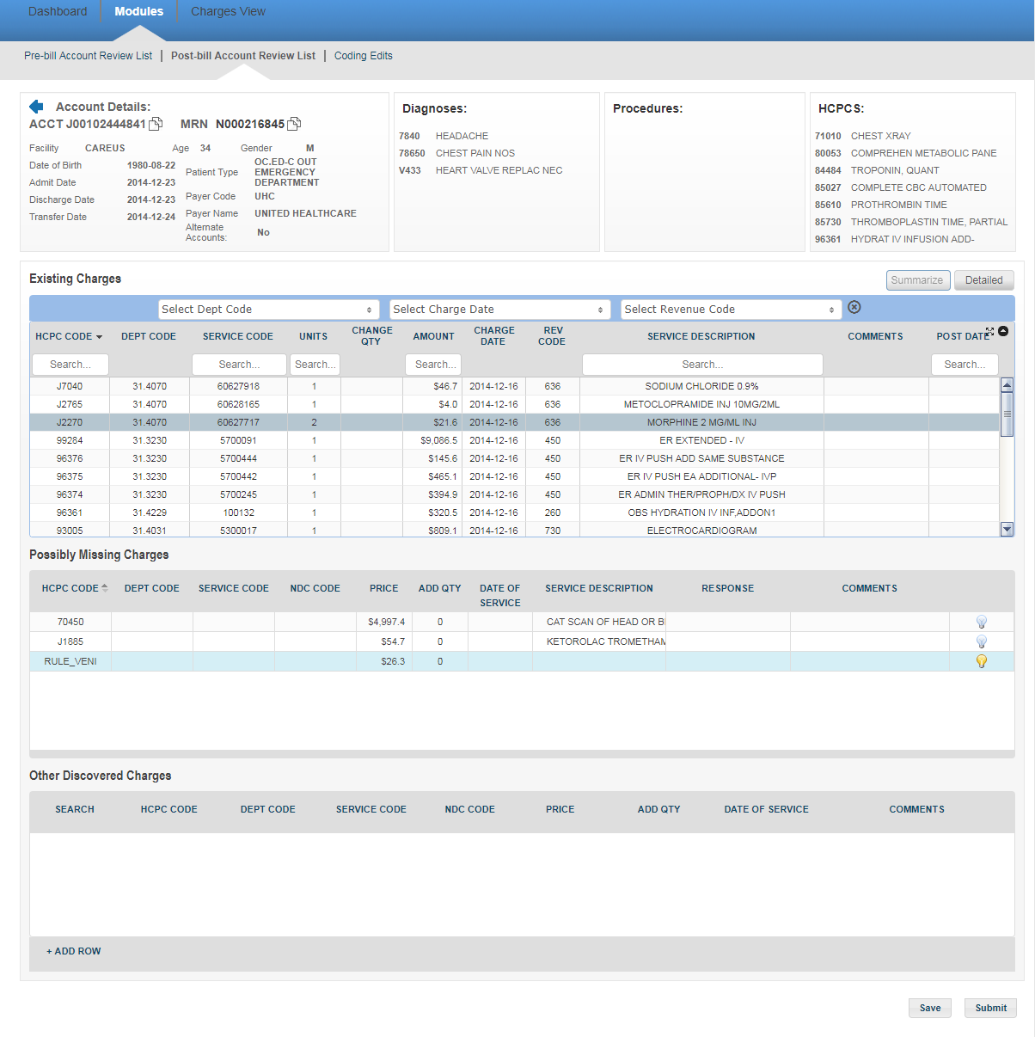

The user can view the account’s personal information like Age, Gender, Date of Birth, Admit Date, Discharge Date, Transfer Date, Patient Type, Payer Code and the Payer’s name on the top-left of the screen. You can also see information about alternate accounts for the same patient (An alternate account is an account with the same Patient ID and same Admit or Discharge Date as the original account). Towards the right, you will find the details about various diagnoses codes, Procedure codes and HCPCs on the account.  You can also use the scroll bar in individual Diagnosis/Procedure/HCPC sections in case the list is long.

You will view **“Existing Charges”, “Possibly Missing Charges”** and **“Other Discovered Charges”**below.

**Existing Charges:**  These charges will include all the hospital charges for treatment and services rendered to the patient. The auditor will audit these charges and can make changes in the quantity, enter his comments and can directly submit the data OR save the information for later purpose without submitting. In the existing charges section, there are two alternate views that the auditors can toggle between. The **Summarized** view is a summed-up view based on the HCPC/charge Code, department, charge date and description. The **Detailed** view is the usual detailed existing charges view. A Blue row in summarized view indicates that once you expand to Detailed view, you’ll be able to see multiple transactions for the same charge.

There are three filters at the top (**Dept Code, Charge Date, and Revenue Code**) using which you may filter the data that is shown in the existing charges table. In the dropdown, you should be able to see the code, description and the total charges amount for the same. Please find below, a screenshot of the same with the dropdown for Revenue Code.



You may select **multiple codes from each of the filters** as per preference and the below table would get updated with the corresponding data. For example, if you were to select revenue codes 272, 300, 301 and dept code 723 in the above table, the below view would be shown. You may click on the cross on the right of the last filter to remove all filters selected.



The Existing Charges grid has following columns:

* **HCPC Code**: This is the healthcare common procedure code.
* **DEPT Code**: This is the department code of the patient.
* **Charge (Service) Code**: This is the code associated with the charge in a facility and department
* **Units**: This is the medication dose which is given to a patient.
* **Change Quantity**: If an auditor feel there should be some change in quantity, he can change the quantity and enter the updated quantity.
* **Amount**: This is the amount of the units consumed by the patient.
* **Charge Date**: This is the date on which the patient is charged.
* **Rev Code**: This is the revenue code associated with the charge code
* **Service Description**: This is a brief description about the various charges incurred on the patient.
* **Comments**: The auditor can write his comments in the area provided.
* **Post Date**: This is the date when the charge was added to the account

You may also search for codes on the account by typing in the search box below each column in the table.

**Possibly Missing Charges:**We use our software solutions to identify missing charges. The auditor can audit the missing charges and give the response.  If auditor agrees for missing charges for an account, the response “**Agree**” can be selected, else any other response from the drop-down list can be selected. After selecting the response, please enter comments as well.



The possibly missing charges grid has following columns:

* **HCPC Code:** These codes are numbers assigned to every task and service a medical practitioner may provide to a patient including medical and diagnostic services.
* **DEPT Code:** Each department in a hospital has a specific code. It conveys essential information quickly without any misunderstanding.
* **Charge (Service) code:**This is the code associated with the charge in a facility and department
* **NDC Code:**This is a code used for Pharmacy charges
* **Price:** This refers to the price of the item/procedure
* **ADD QTY:** This is the quantity of the item to be added
* **Date of Service:**This is the date on which the charge is administered.
* **Charge (Service) Description:** This is a brief description about the various charges incurred on the patient.
* **Response:** The auditor can select the response from the drop-down list. If the agrees for the missing charges, he can select the option **“Agree”**from the drop down list. Accordingly, he can select a different response from the drop down list based on his review. For example, if the auditor feels there is no documentation for this account, he can select the option **“Documentation is not available for review**”.
* **Comments:** The auditor will enter his comments in the area provided.
* **Tool tip (Lightbulb):**This feature can be used to share knowledge obtained on review of same code previously across auditors. It is basically a comment box which can be used by auditors to add information to make it easier for other auditors reviewing the same code. If the bulb is yellow, it means that there are comments already added for the prediction.

**Other Discovered Charges:** These are the charges other than the existing and the missing charges.  This option enables the auditor to add some other miscellaneous charges which could have been missed for a particular account. The auditor can easily search the details even if he knows initial two or three letters of  “**Department Code**” or “**Charge Code**”.



The “Other Discovered Charges” grid has following columns:

* **Search:**This allows the auditor to search the code to be added in the row
* **HCPC Code:**These codes are numbers assigned to every task and service a medical practitioner may provide to a patient including medical and diagnostic services
* **Department Code:**Each department in a hospital has a specific code. It conveys essential information quickly without any misunderstanding.
* **Charge (Service) Code:**This is the code associated with the charge in a facility and department
* **NDC Code:**This is a code used for Pharmacy charges
* **Price:**This refers to the price of the item/procedure
* **Add Quantity:**This is the quantity of the item to be added
* **Date of Service:**This is the date on which the charge is administered
* **Comments:**The auditor will enter his comments in the area provided

The auditor can click on the plus (+) sign  to add a new row to the grid. Clicking on the Search icon will display the “**Other Discovered Charges search form”.**

In search mode, you may use the drop down box to select key criteria by which to search and you may enter those criteria in whole or part. It has four options available for doing the basic search.

* **Equals**
* **Begins with**
* **Ends with**
* **Contains**

* **Equals:** The search results will include only the letters you specify.  For example, entering **“LINEN SAVERS”** as your search string for **“Service description”** would return only one result for the given charge description. Similarly, if you enter **“5412”**as the “**Service code”.**  It will display the record with the matching charge code.

* **Begins with:**The search result will have all of the letters in the beginning which you entered in the search criterion**.** For example, entering **“Department Code”** as **“41”** will return any Department Code that begins with **“41”.**

* **Ends with:** The search results will have all the letters or numbers included   in the end.  For example, entering **“12”**as a search string for  **“ Department  Code”**  will fetch records  like **“312”, “412”, “512”** .

* **Contains:** The search results will have all of the letters   included anywhere in the results which you entered as a search criterion.  For example, entering **“Emer”** as your search String for **“Department Description”**   might return results like “Emergency”, “Emergency OPD”, “Emergency Cardiac” etc.

There are four steps to perform a basic search.

1. Select the search criterion from the drop down box.
2. Enter all or part of the search string.
3. Click the **“Submit”**
4. Review the search results and select the appropriate record.

In the screenshot below, we see that the user elected to search by “**Department code”** using “**equals”** as search criterion.

The auditor can select any specific record and double click on it. The values will be populated in the “**Other Discovered Charges**“ grid.  The auditor can enter his comments on the same.



The auditor can enter the information and click on “**Save”** button. The information will be saved and the account’s row will be highlighted in blue Color in **“Accounts Review** **List”** page. When the auditor logs into the application next time, he knows that changes have been done for this account but they are not yet submitted.   If the auditor clicks on the **“Submit”** button, the information gets saved and the account is removed from the **“Accounts Review List”** page.

# 6. **Confirmed Charge View**

It provides a simple user interface that allows the auditors to evaluate a list of patient accounts for both PRE-BILL and POST-BILL. The auditor is able to view all the charges on which he has agreed/rejected during the auditing process and the amount of revenue likely to be recovered by addressing the missing charges. This way, the auditors can track the most important issues first. Supervisors can evaluate the productivity of their auditors. They can also see how entire hospitals are performing and accordingly assign the hospitals for both PRE-BILL and POST-BILL.

The auditor can select any option either PRE-BILL or POST-BILL. On selecting a particular option, the auditor can next select the hospitals which have missing charges.  Select the **“Start Date”** and the “**End Date”** and click on the “**View”** button.  The application displays the data for selected time period in the tabular format. The rows which are in blue contains those predictions which  are found on the account charges data after our prediction.  If you do not select the **“Start** **Date”** and the **“End Date”** and click on the **“Update”** button, you will get the message**“Please select both Start Date and End Date“.**You may also choose to download the data by clicking on the **Download** button.

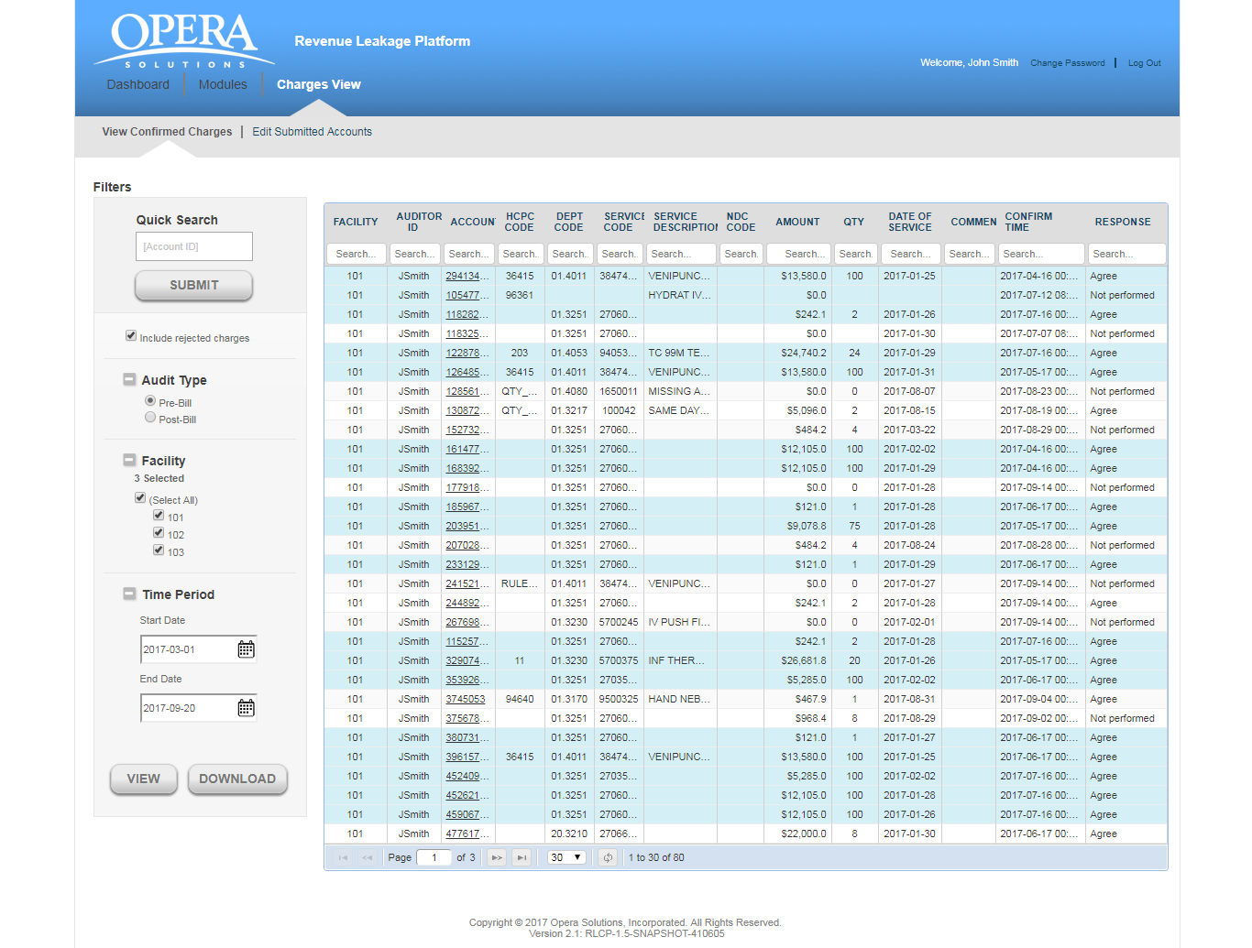

You will view the following details for each account:

* **Facility:** This is the hospital identification number.
* **Auditor ID:** This is the auditor who reviewed the prediction.
* **Account:** It refers to the patient identification number.
* **HCPC Code:** These codes are numbers assigned to every task and service a medical practitioner may provide to a patient including medical and diagnostic services.
* **DEPT Code:** Each department in a hospital has a specific code.
* **Charge (Service) Code:** Since many procedures happen in hospitals, charge code helps to identify different types of charges.
* **Charge (Service) Description:** This is a brief description about the charges incurred on the patient.
* **NDC Code:** This is a code used for identifying Pharmacy charges.
* **Amount:** These are missing charges which the auditor has found for an account in a facility.
* **QTY:**This is the quantity entered by auditor for different procedures undergone by the patient.
* **Date of Service:** This is the service date entered by the auditor when agreeing to the prediction
* **Comments:** These are the auditor’s comments about the missing charges.
* **Confirm Time:** This is the time when auditor confirmed the missing charges.
* **Response:** This is the response from the auditor

If you do not select any hospital and click on the **“View”** button, you will get the message **“Please select at least one facility”.**

If there are no missing charges found for the selected period, you will get the message **“No charges found for the selected period”**.

**Download Excel Report:**  The end user can download the summary report in an excel format by simply clicking the **“Download”** button.

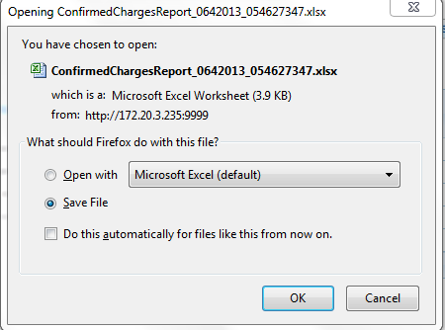

You can directly open the report in excel format ELSE save at a specific location depending on the requirement.

# **Edit Submitted Accounts**

It provides a simple user interface that allows the auditors to edit their already submitted accounts for both PRE-BILL and POST-BILL. The auditor is able to view all the charges on which he has agreed/rejected during the auditing process. If the auditor feels that a change needs to be made to the submitted accounts, those accounts can be selected and the charges changed.

**Caution:** This functionality can be only used on the same day of submission of the account before consolidated reports are sent to facilities.

The auditor can select any option either PRE-BILL or POST-BILL. On selecting a particular option, the auditor can next select the hospitals and click on the “**Update”** button.  The application displays the data in the tabular format.

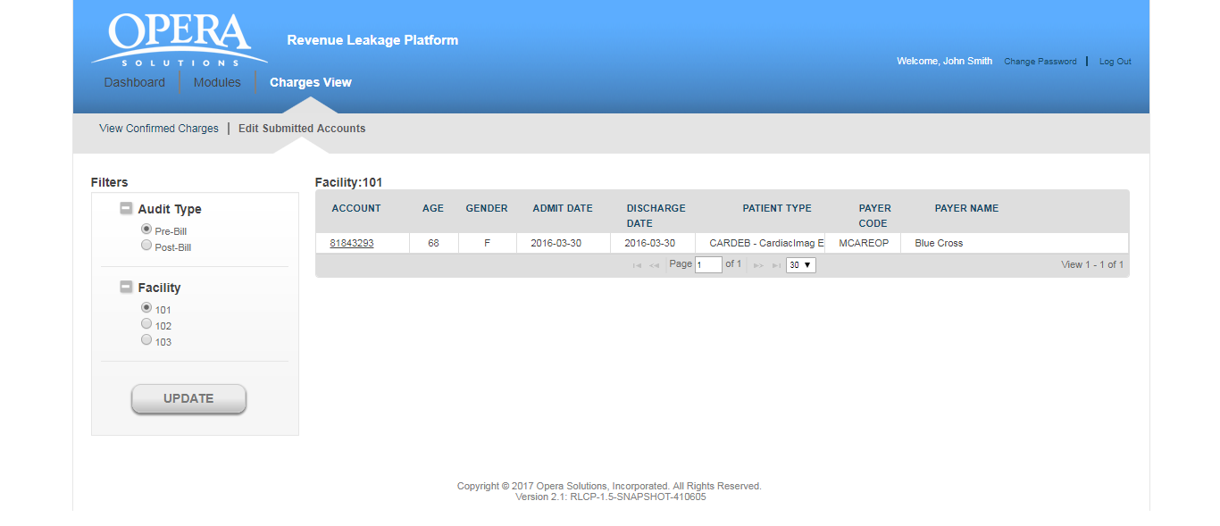

You will view the following details for each account:

* **Account**: It refers to the patient identification number.
* **Age**: It shows the age of the patient.
* **Gender**: It refers to the Gender of the patient.
* **Admit** **Date**: It is the date on which the patient was admitted.
* **Discharge** **Date**: It is the date on which the patient was discharged from the facility
* **Patient** **Type**: There can be different types of patients. For example, OUTPATIENT, INPATIENT and EMERGENCY.
  + - **OUTPATIENT** care is any healthcare service provided to a patient who is not admitted to a hospital.
    - **INPATIENT** care is any healthcare service provided to a patient who is admitted to a hospital.
    - **EMERGENCY** care is provided to the patients who need urgent care because of the illness or accident.
* **Payer** **code**: Health care providers follow up on claims to insurance companies (payer) in order to receive payment for the services which they have rendered to the patients. The payer code refers to the insurance company code.
* **Payer** **Name**: This is the name of the insurance company.

If you do not select any hospital and click on the **“Update”** button, you will get the message **“Please select at least one facility”.**

If there are no account reviews found for the selected facility, you will get the message **“No account review is pending for the facility”.**

# **Coding edits Accounts**

**Overview**

**National Correct Coding Initiative**:

The CMS developed the National Correct Coding Initiative (NCCI) to promote national correct coding methodologies and to control improper coding leading to inappropriate payment. Opera has developed algorithm for healthcare clients to avoid such improper coding while submission of bill to payers. These NCCI Edits can be categorized into three categories: **PTP , MUE and Add-on** code edits.

**PTP Coding Edits (Code pair):**

Also Known as **Code Pair edits** or **Pair to Pair** edits. These are set of rules which gives code pair which should not be present in the bill of a patient on the same date of service.

**Medically Unlikely Edits (MUE)**

A **MUE** for a HCPCS/CPT code is the maximum units of service that a provider would report under most circumstances for a single beneficiary on a single date of service.

**Add-on Code Edits (Add on)**

An **add-on code** is a HCPCS/CPT code that describes a service that is always performed in conjunction with another primary service.  An add-on code with one exception is eligible for payment only if it is reported with an appropriate primary procedure performed by the same practitioner. An add-on code with one exception is never eligible for payment if it is the only procedure reported by a practitioner.

It shows all the **EDITS** accounts of different hospitals which have been assigned to an auditor.

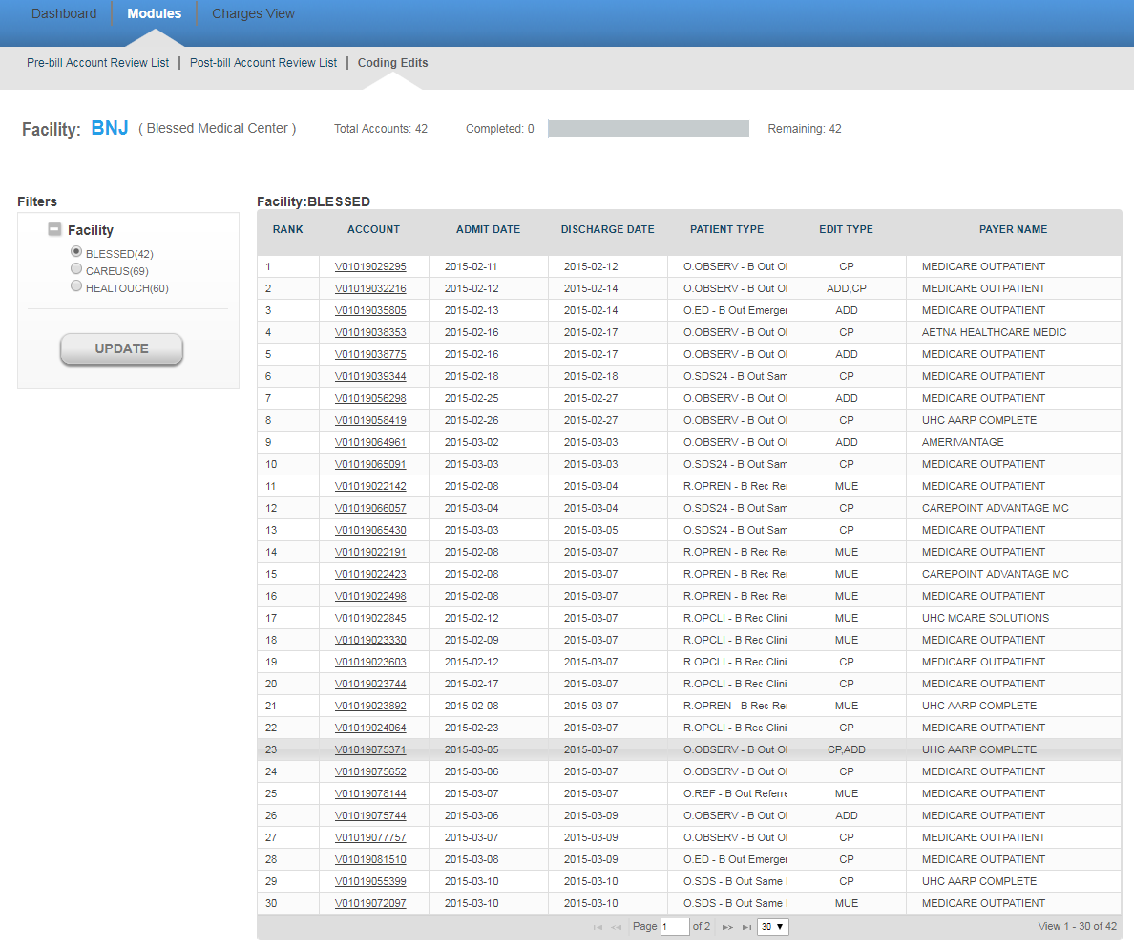

For viewing accounts of a hospital, select the hospital ID (which also shows a breakdown of accounts still to be reviewed - by each facility) from the Filter panel on the left and click on Update and the application will display all the accounts of that facility.  If no account is pending for review, the auditor will get the message “No Account Review is pending for the Facility”.

You will view the following details for an account:

* **Rank**: It refers to the rank of that particular account for review, as calculated by Opera.
* **Account**: It refers to the patient identification number.
* **Admit** **Date**: It is the date when patient got admitted to the hospital.
* **Discharge** **date**: This is the date when patient got discharged from the hospital.
* **Patient** **Type**: There can be different types of patients. For example, OUTPATIENT, INPATIENT and **EMERGENCY**.
  + - **OUTPATIENT** care is any healthcare service provided to a patient who is not admitted to a hospital.
    - **INPATIENT** care is any healthcare service provided to a patient who is admitted to a hospital.
    - **EMERGENCY** care is provided to the patients who need urgent care because of the illness or accident.
* **Edit** **Type**: There can be 3 different types of edit types. For example, CP, ADD, MUE
  + - **CP** - These are set of rules which gives code pair which should not be present in the bill of a patient on the same date of service.
    - **ADD An add-on** code is a HCPCS/CPT code that describes a service that is always performed in conjunction with another primary service.
    - **MUE** - MUE for a HCPCS/CPT code is the maximum units of service that a provider would report under most circumstances for a single beneficiary on a single date of service.
* **Payer Name**: This is the name of the insurance company.

You can also navigate through multiple pages of records by making use of navigation bar given at the bottom of the screen.

Click on any account and you are directed to the “CODING-EDITS ACCOUNT DETAILS” page.

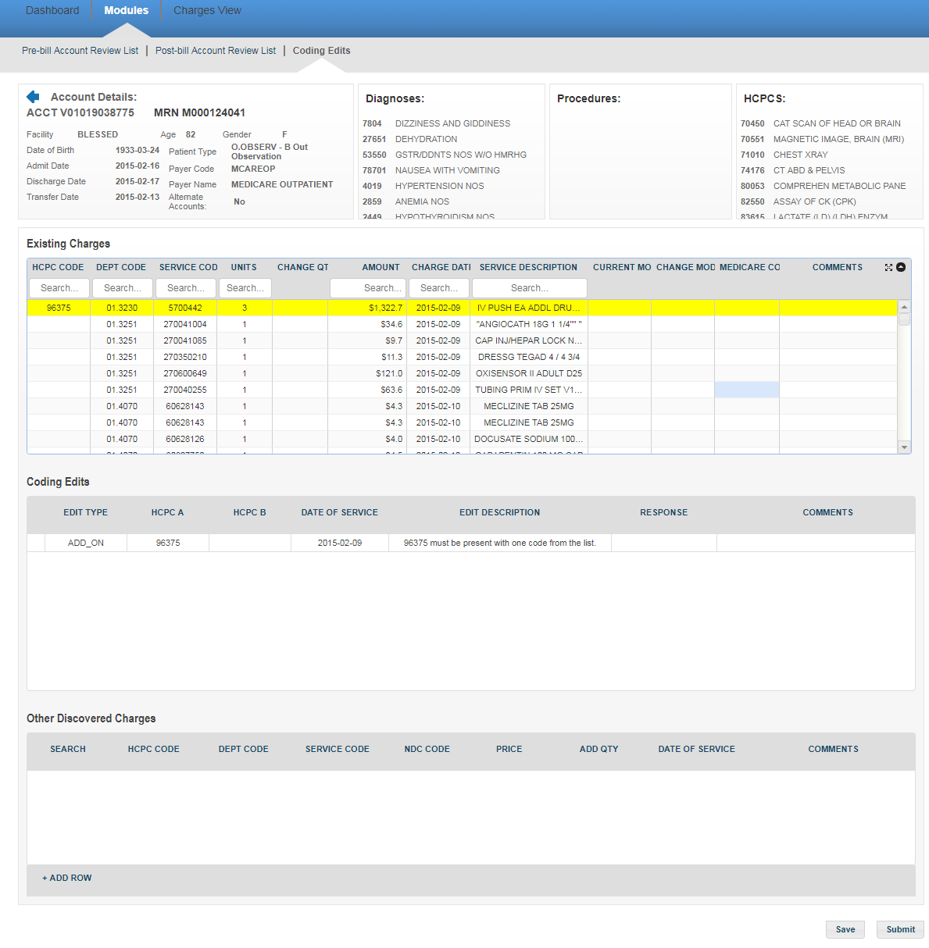

The user can view the account’s personal information like Age, Gender, Date of Birth, Admit Date, Discharge Date, Transfer Date, Patient Type, Payer Code and the Payer’s name on the top-left of the screen. You can also see information about alternate accounts for the same patient (An alternate account is an account with the same Patient ID and same Admit or Discharge Date as the original account). Towards the right, you will find the details about various diagnoses codes, Procedure codes and HCPCs on the account.  You can also use the scroll bar in individual Diagnosis/Procedure/HCPC sections in case the list is long.

You will view **“Existing Charges”, “Coding Edits”** and **“Other Discovered Charges”**below.

**Existing Charges:** These charges will include all the hospital charges for treatment and services rendered to the patient. The auditor will audit these charges and can make changes in the quantity, enter his comments and can directly submit the data OR save the information for later purpose without submitting.

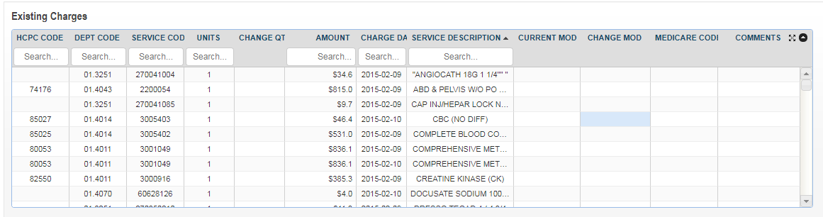

The Existing Charges grid has following columns:

* **HCPC Code:** This is the healthcare common procedure code.
* **DEPT Code:** This is the department code of the patient.
* **Charge (Service) Code:**This is the code associated with the charge in a facility and department
* **Units:** This is the medication dose which is given to a patient.
* **Change Quantity:** If an auditor feel there should be some change in quantity, he can change the quantity

and enter the updated quantity.

* **Amount:** This is the amount of the units consumed by the patient.
* **Charge Date:** This is the date on which the patient is charged.
* **Service Description:** This is a brief description about the various charges incurred on the patient.
* **Current Mod:** This is to show current modifier details
* **Change Mod**: This is an editable field. We can change modifier in it.
* **Medicare Code**: This will show Medicare code.
* **Comments:** The auditor can write his comments in the area provided.

You may also search for codes on the account by typing in the search box below each column in the table.

**Coding Edits:**

We use our software solutions to identify CCI-edits types. The auditor can audit the cci-edits and give the response.  We have change the row based on Edit type column. User can select any response based on modification. After selecting the response, please enter comments as well.

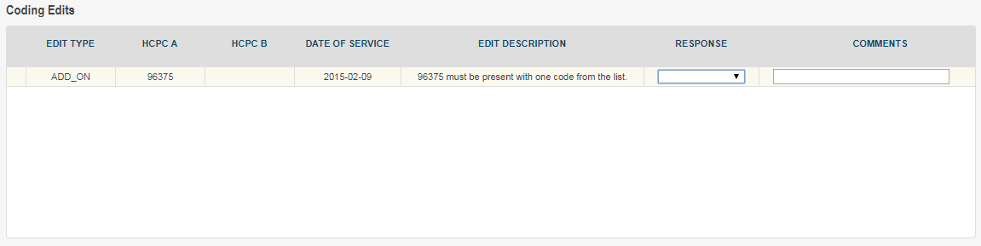

The CCI-edits has following columns:

* **Edit type:** These codes are basically Add-on, MUE and code pair.
* **HCPC A :**  This is the code associated to row.
* **HCPC B:**This is the code associated to row.
* **Date of Service:**This is the date on which the edit is administered.
* **Edit Description:** This is a brief description about Edit type.
* **Response:** The auditor can select the response from the drop-down list
* **Comments:** The auditor will enter his comments in the area provided.

**Other Discovered Charges:** These are the charges other than the existing and the missing charges.  This option enables the auditor to add some other miscellaneous charges which could have been missed for a particular account. The auditor can easily search the details even if he knows initial two or three letters of  “**Department Code**” or “**Charge Code**”.



The “Other Discovered Charges” grid has following columns:

* **Search:**This allows the auditor to search the code to be added in the row
* **HCPC Code:**These codes are numbers assigned to every task and service a medical practitioner may provide to a patient including medical and diagnostic services
* **Department Code:**Each department in a hospital has a specific code. It conveys essential information quickly without any misunderstanding.
* **Charge (Service) Code:**This is the code associated with the charge in a facility and department
* **NDC Code:**This is a code used for Pharmacy charges
* **Price:**This refers to the price of the item/procedure
* **Add Quantity:**This is the quantity of the item to be added
* **Date of Service:**This is the date on which the charge is administered
* **Comments:**The auditor will enter his comments in the area provided

The auditor can click on the plus (+) sign  to add a new row to the grid. Clicking on the Search icon will display the “**Other Discovered Charges search form”.**

In search mode, you may use the drop down box to select key criteria by which to search and you may enter those criteria in whole or part. It has four options available for doing the basic search.

* **Equals**
* **Begins with**
* **Ends with**
* **Contains**

* **Equals:** The search results will include only the letters you specify.  For example, entering **“LINEN SAVERS”** as your search string for **“Service description”** would return only one result for the given charge description. Similarly, if you enter **“5412”**as the “**Service code”.**  It will display the record with the matching charge code.

* **Begins with:**The search result will have all of the letters in the beginning which you entered in the search criterion**.** For example, entering **“Department Code”** as **“41”** will return any Department Code that begins with **“41”.**

* **Ends with:** The search results will have all the letters or numbers included   in the end.  For example, entering **“12”**as a search string for  **“ Department  Code”**  will fetch records  like **“312”, “412”, “512”** .

* **Contains:** The search results will have all of the letters   included anywhere in the results which you entered as a search criterion.  For example, entering **“Emer”** as your search String for **“Department Description”**   might return results like “Emergency”, “Emergency OPD”, “Emergency Cardiac” etc.

There are four steps to perform a basic search.

1. Select the search criterion from the drop down box.
2. Enter all or part of the search string.
3. Click the **“Submit”**
4. Review the search results and select the appropriate record.

In the screenshot below, we see that the user elected to search by “**Department code”** using “**equals”** as search criterion.

The auditor can select any specific record and double click on it. The values will be populated in the “**Other Discovered Charges**“ grid.  The auditor can enter his comments on the same.



The auditor can enter the information and click on “**Save”** button. The information will be saved and the account’s row will be highlighted in blue Color in **“Accounts Review** **List”** page. When the auditor logs into the application next time, he knows that changes have been done for this account but they are not yet submitted.   If the auditor clicks on the **“Submit”** button, the information gets saved and the account is removed from the **“Accounts Review List”** page.

# **Coding Edits Submitted Accounts**

It provides a simple user interface that allows the auditors to edit their already submitted accounts for CCI Edits. The auditor is able to view all the charges on which he has agreed/rejected during the auditing process. If the auditor feels that a change needs to be made to the submitted accounts, those accounts can be selected and the charges changed.

**Caution:** This functionality can be only used on the same day of submission of the account before consolidated reports are sent to facilities.

The auditor can select Facility from filter panel. On selecting a particular option, the auditor can next select the hospitals and click on the “**Update”** button.  The application displays the data in the tabular format.

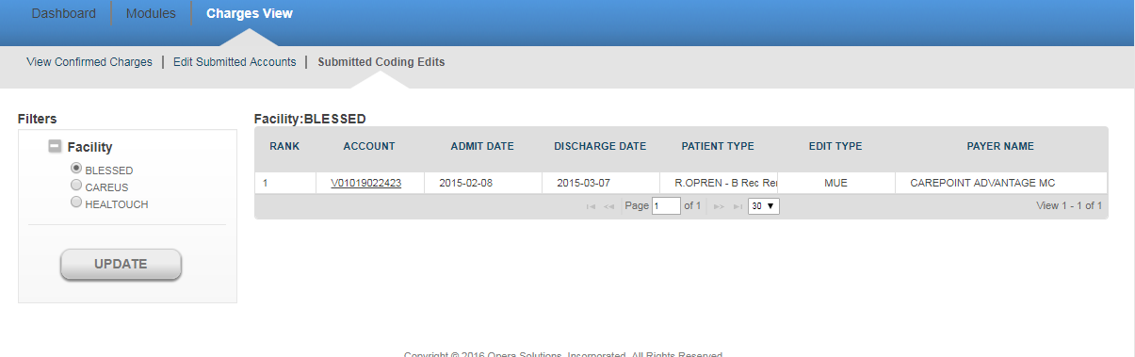

You will view the following details for each account:

* **Account:** It refers to the patient identification number.
* **Age:** It shows the age of the patient.
* **Gender:** It refers to the Gender of the patient.
* **Admit Date:** It is the date on which the patient was admitted.
* **Discharge Date:**It is the date on which the patient was discharged from the facility
* **Patient Type:**There can be different types of patients. For example, OUTPATIENT, INPATIENT and

EMERGENCY.

* + OUTPATIENT care is any healthcare service provided to a patient who is not admitted to a hospital.
  + INPATIENT care is any healthcare service provided to a patient who is admitted to a hospital.
  + EMERGENCY care is provided to the patients who need urgent care because of the illness or accident.
* **Payer code:** Health care providers follow up on claims to insurance companies (payer) in order to

receive payment for the services which they have rendered to the patients. The payer code refers to the insurance company code.

* **Payer Name:** This is the name of the insurance company.

If you do not select any hospital and click on the **“Update”** button, you will get the message **“Please select at least one facility”.**

If there are no account reviews found for the selected facility, you will get the message **“No account review is pending for the facility”.**

You will view the following details for an account:

* **Rank:**It refers to the rank of that particular account for review, as calculated by Opera.
* **Account:** It refers to the patient identification number.
* **Admit Date:** It is the date when patient got admitted to the hospital.
* **Discharge date:** This is the date when patient got discharged from the hospital.
* **Patient Type:** There can be different types of patients. For example, OUTPATIENT, INPATIENT and

EMERGENCY.

* + OUTPATIENT care is any healthcare service provided to a patient who is not admitted to a

hospital.

* + INPATIENT care is any healthcare service provided to a patient who is admitted to a hospital.
  + EMERGENCY care is provided to the patients who need urgent care because of the illness or

accident.

* **Edit Type:** There can be 3 different types of edit types. For example, CP, ADD, MUE
  + CP - These are set of rules which gives code pair which should not be present in the bill of a

patient on the same date of service.

* + ADD An **add-on code** is a HCPCS/CPT code that describes a service that is always performed

in conjunction with another primary service.

* + MUE - **MUE** for a HCPCS/CPT code is the maximum units of service that a provider would

report under most circumstances for a single beneficiary on a single date of service.

* **Payer Name:** This is the name of the insurance company.

You can also navigate through multiple pages of records by making use of navigation bar given at the bottom of

the screen.

Click on any account and you are directed to the “SUBMITTED CODING-EDITS ACCOUNT DETAILS” page.